**BootStrap Introduction and Installation**

Bootstrap is a free and open-source collection of tools for creating websites and web applications. It is the most popular HTML, CSS, and JavaScript framework for developing responsive, mobile-first websites. It solves many problems which we had once, one of which is the cross-browser compatibility issue. Nowadays, the websites are perfect for all the browsers (IE, Firefox, and Chrome) and for all sizes of screens ( Desktop, Tablets, Phablets, and Phones). All thanks to Bootstrap developers -Mark Otto and Jacob Thornton of Twitter, though it was later declared to be an open-source project.

**Reason to choose Bootstrap:**

* Faster and Easier Web-Development.
* It creates Platform-independent web-pages.
* It creates Responsive Web-pages.
* It’s designed to be responsive to mobile devices too.
* It’s Free! Available on www.getbootstrap.com

Websites that were built with a lot of CSS and JavaScript can now be built with a few lines of code using Bootstrap. Bootstrap comprises of mainly three components:

* CSS
* Fonts
* Javascript

**Installing Bootstrap:** There are two ways in which we can install Bootstrap. I will talk about both ways of Installing Bootstrap. But before installing Bootstrap, we must code a basic html document on which we would install Bootstrap. Here it is,

**Example:**

* HTML

|  |
| --- |
| <!DOCTYPE html>  <**html** lang="en">  <**head**>      <**meta** charset="utf-8">      <**title**>Learning Bootstrap @ GeeksforGeeks.org</**title**>      <**meta** name="description" content="Hello World">  </**head**>  <**body**>        <**div**> Hello World!</**div**>        <**div**> You're learning Bootstrap on Geeksforgeeks.org</**div**>  </**body**>  </**html**> |

**Method 1 (BootstrapCDN):** This method of installing Bootstrap is fairly easy but it requires Internet connection. It is highly recommended that you follow this method.

**Step 1:** Goto [getbootstrap](https://getbootstrap.com/" \t "_blank) and click Getting Started . Scroll down.

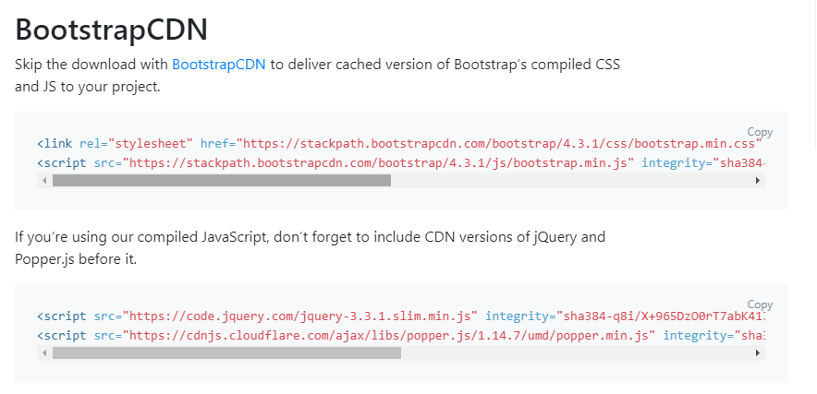

* **Step 2:** Copy the <link> and paste it in the head section of the HTML code.
* HTML

|  |
| --- |
| <!DOCTYPE html>  <**html** lang="en">  <**head**>      <**meta** charset="utf-8">      <**title**>Learning Bootstrap @ GeeksforGeeks.org</**title**>      <**meta** name="description" content="Hello World">      <**link** rel="stylesheet" href=  "<https://stackpath.bootstrapcdn.com/bootstrap/4.3.1/css/bootstrap.min.css>"          integrity=  "sha384-ggOyR0iXCbMQv3Xipma34MD+dH/1fQ784/j6cY/iJTQUOhcWr7x9JvoRxT2MZw1T"          crossorigin="anonymous">  </**head**>  <**body**>      <**div**>Hello World!</**div**>      <**div**>You're learning Bootstrap on Geeksforgeeks.org</**div**>      <**script** src=  "<https://code.jquery.com/jquery-3.3.1.slim.min.js>"          integrity=  "sha384-q8i/X+965DzO0rT7abK41JStQIAqVgRVzpbzo5smXKp4YfRvH+8abtTE1Pi6jizo"          crossorigin="anonymous">      </**script**>      <**script** src=  "<https://cdnjs.cloudflare.com/ajax/libs/popper.js/1.14.7/umd/popper.min.js>"          integrity=  "sha384-UO2eT0CpHqdSJQ6hJty5KVphtPhzWj9WO1clHTMGa3JDZwrnQq4sF86dIHNDz0W1"          crossorigin="anonymous">      </**script**>      <**script** src=  "<https://stackpath.bootstrapcdn.com/bootstrap/4.3.1/js/bootstrap.min.js>"          integrity=  "sha384-JjSmVgyd0p3pXB1rRibZUAYoIIy6OrQ6VrjIEaFf/nJGzIxFDsf4x0xIM+B07jRM"          crossorigin="anonymous">      </**script**>  </**body**>  </**html**> |

**Step 3:**Copy the <script> tag and paste those things in the body section at bottom position like the above code.

**Step 4:** Bingo! You’ve installed Bootstrap on your html document. To see the changes on your document, try opening the page on a separate tab of your browser and you can easily notice the difference between the two codes. Though, not much of difference can be felt till now, but it would be apparent in the later parts of the article. Here, the one on the left is without bootstrap and the one on the right is with bootstrap installed.

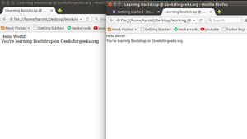

**Method 2(Compiled CSS and JS):** This method of installing bootstrap is also easy but it can work offline ( doesn’t require an internet connection ) but it might not work for some browsers.

* **Step 1:** Goto [getbootstrap](https://getbootstrap.com/" \t "_blank) and click Getting Started. Click on the Download Bootstrap button and download the compiled CSS and JS.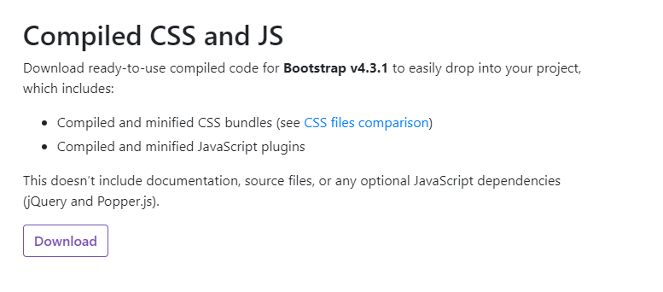

**Step 2:** A.zip file would get downloaded. Extract it and go into the distribution folder. You would see 2 folders named CSS and JS. You can make your HTML file there and then you must paste these links in their respective sections.

*<link rel=”stylesheet” type=”text/css” href=”css/bootstrap.min.css”> <script src=”js/bootstrap.min.js”></script> <script src= “https://ajax.googleapis.com/ajax/libs/jquery/2.1.3/jquery.min.js”> </script>*

* HTML

|  |
| --- |
| <!DOCTYPE html>  <**html** lang="en">  <**head**>      <**meta** charset="utf-8">      <**title**>Learning Bootstrap @ GeeksforGeeks.org</**title**>      <**meta** name="description" content="Hello World">      <**link** rel="stylesheet" type="text/css"          href="css/bootstrap.min.css">  </**head**>  <**body**>      <**div**> Hello World!</**div**>      <**div**> You're learning Bootstrap on Geeksforgeeks.org</**div**>      <**script** src="js/bootstrap.min.js"></**script**>      <**script** src=  "<https://ajax.googleapis.com/ajax/libs/jquery/2.1.3/jquery.min.js>">      </**script**>  </**body**>  </**html**> |

**HTML 3:** Open the HTML document with the browser and see the difference which bootstrap makes! This would probably not support higher versions of Internet Explorer(8+) and for them we need to download additional files which is cumbersome. So, It is highly recommended to follow Method A which is really very simple.

**Bootstrap Buttons, Glyphicons, Tables**

After the [previous](https://www.geeksforgeeks.org/bootstrap-part-2/) article, one should be familiar with the Grid System of Bootstrap. Now, we’ll learn about making Buttons, the all new Glyphicons and Tables. Lets get started.

**Beautiful Buttons:**

We can make Buttons in Bootstrap in two ways ( or more specifically, using two tags ). Firstly, with the  <a> tag and secondly by using the <button> tag.

<a href="https://www.geeksforgeeks.org"class="btn btn-danger">

Button with'a'tag </a>

<button type="button" class="btn btn-info" >Button with 'button' tag </button>

We can have Buttons in different colours using Bootstrap. Each having a specific name like btn-default, btn-primary, btn-success, btn-info, btn-warning, btn-danger and btn-link. All of them represent a specific colour of button.

We can also make buttons of different sizes ( by using btn-lg, btn-sm, btn-xs and btn-block attributes)

* <a href=” “>Button with <a> tag </a>  
  **Example:**

|  |
| --- |
| <!DOCTYPE html>  <**html** lang="en">  <**head**>    <**title**>Bootstrap Example</**title**>    <**meta** charset="utf-8">    <**meta** name="viewport" content="width=device-width, initial-scale=1">    <**link** rel="stylesheet" href="<https://maxcdn.bootstrapcdn.com/bootstrap/3.4.0/css/bootstrap.min.css>">    <**script** src="<https://ajax.googleapis.com/ajax/libs/jquery/3.4.0/jquery.min.js>"></**script**>    <**script** src="<https://maxcdn.bootstrapcdn.com/bootstrap/3.4.0/js/bootstrap.min.js>"></**script**>  </**head**>  <**body**>      <**div** class="container" style="color:green">       <**h1**>GeeksforGeeks</**h1**>      </**div**>  <**div** class="container">    <**h2**>Button Styles</**h2**>    <**button** type="button" class="btn">Basic</**button**>    <**button** type="button" class="btn btn-default">Default</**button**>    <**button** type="button" class="btn btn-primary">Primary</**button**>    <**button** type="button" class="btn btn-success">Success</**button**>    <**button** type="button" class="btn btn-info">Info</**button**>    <**button** type="button" class="btn btn-warning">Warning</**button**>    <**button** type="button" class="btn btn-danger">Danger</**button**>  </**div**>  <**br**>    <**div** class="container">    <**h4**>Button with <**a**> and  <**button**> tag</**h4**>    <**a** href="<https://ide.geeksforgeeks.org/tryit.php>"class="btn btn-danger">      Button with <**a**> tag </**a**>    <**button** type="button" class="btn btn-success">Button with <**button**> tag </**button**>  </**div**>    </**body**>  </**html**> |

* **Output:**  
  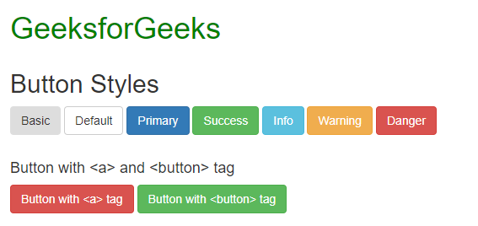
* **Gorgeous Glyphicons:**

Glyphicons is a library of precisely prepared monochromatic icons and symbols, created with an emphasis to simplicity and easy orientation. We can use Glyphicons inside the span tag like this:

<span class="Name of the glyphicon"> </span>

Glyphicons can also be used within buttons like this:

<a href="" class="btn btn-default"><span class="Name of the glyphicon"> </span> </a>

One can see all the glyphicons available at <http://getbootstrap.com/components> for free. You can copy their names and paste within the quotes  class=”Paste here”. If you need more specific glyphicon you can visit <http://glyphicons.com/> and buy them.

**Example:**

|  |
| --- |
| <!DOCTYPE html>  <**html** lang="en">  <**head**>    <**title**>Bootstrap Example</**title**>    <**meta** charset="utf-8">    <**meta** name="viewport" content="width=device-width, initial-scale=1">    <**link** rel="stylesheet" href="<https://maxcdn.bootstrapcdn.com/bootstrap/3.4.0/css/bootstrap.min.css>">    <**script** src="<https://ajax.googleapis.com/ajax/libs/jquery/3.4.0/jquery.min.js>"></**script**>    <**script** src="<https://maxcdn.bootstrapcdn.com/bootstrap/3.4.0/js/bootstrap.min.js>"></**script**>  </**head**>  <**body**>      <**div** class="container" style="color:green">       <**h1**>GeeksforGeeks</**h1**>        </**div**>      <**div** class="container">          <**p**>Correct<**span** class="glyphicon glyphicon-ok"></**span**></**p**>          <**p**>Incorrect<**span** class="glyphicon glyphicon-remove"></**span**></**p**>          <**h4**>Glyphicon with buttons</**h4**>          <**a** href="[https://www.geeksforgeeks.org](https://www.geeksforgeeks.org/)"class="btn btn-primary">              <**span** class="glyphicon glyphicon-backward"></**span**>          </**a**>          <**a** href="[https://www.geeksforgeeks.org](https://www.geeksforgeeks.org/)"class="btn btn-danger">              <**span** class="glyphicon glyphicon-pause"></**span**>          </**a**>          <**a** href="[https://www.geeksforgeeks.org](https://www.geeksforgeeks.org/)"class="btn btn-success">              <**span** class="glyphicon glyphicon-play"></**span**>          </**a**>          <**a** href="[https://www.geeksforgeeks.org](https://www.geeksforgeeks.org/)"class="btn btn-primary">              <**span** class="glyphicon glyphicon-forward"></**span**>          </**a**>      </**div**>      <**br**>      <**div** class="container">          <**a** href="[https://www.geeksforgeeks.org](https://www.geeksforgeeks.org/)"class="btn btn-primary">          <**span** class="glyphicon glyphicon-thumbs-up"></**span**>Like Button      </**a**>      </**div**>  </**body**>  </**html**> |

**Output:**  
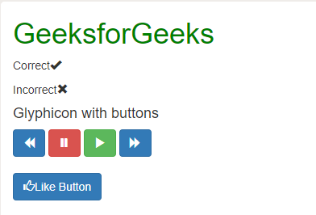

* **Tantalizing Tables:**

For creating tables, we need the <table> tag within which we use <tr> tag to define each row and <td>/<th> tag to represent actual data cell. In the table tag we can add different classes attributed to them which can make our table look better. Some of the table classes would be table-striped, table-bordered, table-hover, table-condensed, etc. You can find all the table classes [here](http://getbootstrap.com/css/#tables). The basic structure of the table is :

<table class="table-striped">

<tr>

<td>First Column</td>

<td>Second Column</td>

<td>Third Column</td>

</tr>

</table>

You can also add different colours to each row of the table using the colour in the

<tr> tag like <tr class=”danger”> </tr>

Similarly, you can also add colours to each cell by including the class of colours in the <td> tag.  
**Example:**

* + html

|  |
| --- |
| <!DOCTYPE html>  <**html** lang="en">  <**head**>    <**title**>Bootstrap Example</**title**>    <**meta** charset="utf-8">    <**meta** name="viewport" content="width=device-width, initial-scale=1">    <**link** rel="stylesheet" href="<https://maxcdn.bootstrapcdn.com/bootstrap/3.4.0/css/bootstrap.min.css>">    <**script** src="<https://ajax.googleapis.com/ajax/libs/jquery/3.4.0/jquery.min.js>"></**script**>    <**script** src="<https://maxcdn.bootstrapcdn.com/bootstrap/3.4.0/js/bootstrap.min.js>"></**script**>  </**head**>  <**body**>      <**div** class="container" style="color:green">       <**h1**>GeeksforGeeks</**h1**>        </**div**>      <**div** class="container">          <**h4**>Tables using Bootstrap</**h4**>          <**hr**><**hr**>          <**div** class="container">              <**div** class="bg bg-success">                  <**table** class="table table-hover">                     <**tr** class="danger">                      <**td**>First Column</**td**>                      <**td**>Second Column</**td**>                      <**td**>Third Column</**td**>                     </**tr**>                     <**tr** class="info">                      <**td**>Python</**td**>                      <**td**>Java</**td**>                      <**td**>Swift</**td**>                     </**tr**>                     <**tr** class="danger">                      <**td**>HTML</**td**>                      <**td**>CSS</**td**>                      <**td**>JavaScript</**td**>                     </**tr**>                     <**tr** class="info">                      <**td**>MySql</**td**>                      <**td**>MongoDB</**td**>                      <**td**>SQL lit</**td**>                     </**tr**>                  </**table**>              </**div**>         </**div**>     </**div**>  </**body**>  </**html**> |

**Output:**  
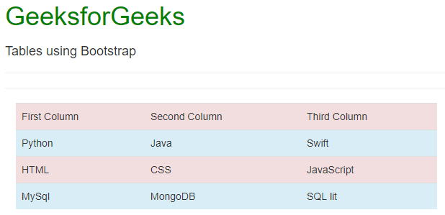

**Supported Browsers:**

* + Google Chrome
  + Microsoft Edge
  + Firefox
  + Opera
  + Safari

**Bootstrap Vertical Forms, Horizontal Forms, Inline Forms**

**Forms**:

Bootstrap provides 3 types of form layout, namely:

* Vertical Forms (Default)
* Horizontal Forms
* Inline Forms

We’ll look into each of them separately:

**Vertical Forms:**

First of all, we’ll initialize the form using the <form> tag. We’ll wrap all the labels and form controls inside the tag <div class=”form-group”>. This is needed for optimum spacing between the form components.

Now, we can design the form within these tags as per our needs. We can use a label to define a label for an input element. Remember that the <for> attribute of the <label> tag should be equal to the id attribute of the related element to bind them together. After the label tag, one can enter the <input> tag that specifies an input field where the user can enter data. The class to be used inside the input tag must be class=”form-control”. One can also use the placeholder attribute which specifies a short hint that describes the expected value of an input field.

**Example:**

* HTML

|  |
| --- |
| <!DOCTYPE html>  <**html** lang="en">  <**head**>      <**title**>Bootstrap Example</**title**>      <**meta** charset="utf-8">      <**meta** name="viewport"          content="width=device-width, initial-scale=1">      <**link** rel="stylesheet" href=  "<https://maxcdn.bootstrapcdn.com/bootstrap/3.4.0/css/bootstrap.min.css>">      <**script** src=  "<https://ajax.googleapis.com/ajax/libs/jquery/3.4.0/jquery.min.js>">      </**script**>      <**script** src=  "<https://maxcdn.bootstrapcdn.com/bootstrap/3.4.0/js/bootstrap.min.js>">      </**script**>  </**head**>  <**body**>      <**div** class="container" style="color:green">          <**h1**>GeeksforGeeks</**h1**>      </**div**>      <**div** class="container">          <**h4**>Vertical Form</**h4**>          <**form** action="">              <**div** class="form-group">                  <**label** for="id1">User Name</**label**>                  <**input** class="form-control" type="text"                      id="id1" placeholder="Enter your User Name">              </**div**>              <**div** class="form-group">                  <**label** for="id2">Password</**label**>                  <**input** class="form-control" type="password"                      id="id2" placeholder="Enter your password">              </**div**>              <**div** class="container">                  <**button** type="button" class="btn btn-success">                      Login                  </**button**>                  <**button** type="button" class="btn btn-secondary">                      Register                  </**button**>              </**div**>          </**form**>      </**div**>  </**body**>  </**html**> |

**Output:**

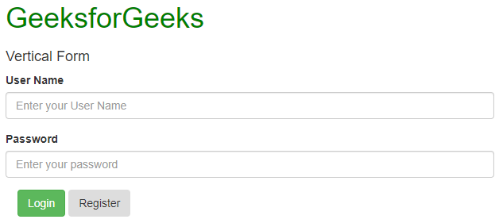

**Horizontal Forms:**

Horizontal forms are different from Vertical forms not only in the amount of markup but also in the presentation of the form. To make a form horizontal, add  class=”form-horizontal” in the <form> element. If you’re using the <label> element then you must use class=”control-label”. Also, remember that you can use Bootstrap’s predefined grid classes to align labels and groups of form controls in a horizontal layout.

You can also add particular styles to the labels and input fields. Add any of the classes has-warning, has-success, has-error, etc. in the <div> tag which contains a class that has a form-group to give it different effects when selected.

**Example:**

* HTML

|  |
| --- |
| <!DOCTYPE html>  <**html** lang="en">  <**head**>      <**title**>Bootstrap Example</**title**>      <**meta** charset="utf-8">      <**meta** name="viewport"          content="width=device-width, initial-scale=1">      <**link** rel="stylesheet" href=  "<https://maxcdn.bootstrapcdn.com/bootstrap/3.4.0/css/bootstrap.min.css>">      <**script** src=  "<https://ajax.googleapis.com/ajax/libs/jquery/3.4.0/jquery.min.js>">      </**script**>      <**script** src=  "<https://maxcdn.bootstrapcdn.com/bootstrap/3.4.0/js/bootstrap.min.js>">      </**script**>  </**head**>  <**body**>      <**div** class="container" style="color:green">          <**h1**>GeeksforGeeks</**h1**>      </**div**>      <**div** class="container">          <**h4**>Horizontal Form</**h4**>          <**form** action="" class="form-horizontal">              <**div** class="form-group has-success">                  <**label** class="control-label col-sm-2"                      for="id1">Username</**label**>                  <**div** class="col-sm-6">                      <**input** class="form-control" type="text"                          id="id1" placeholder="Enter your User Name">                  </**div**>              </**div**>              <**div** class="form-group has-success">                  <**label** class="control-label col-sm-2"                      for="id2">Password</**label**>                  <**div** class="col-sm-6">                      <**input** class="form-control" type="password"                          id="id2" placeholder="Enter your password">                  </**div**>              </**div**>              <**div** class="container">                  <**button** type="button" class="btn btn-success">                      Login                  </**button**>                  <**button** type="button" class="btn btn-secondary">                      Register                  </**button**>                  <**label**>                      <**input** type="checkbox">                          Remember me                  </**label**>              </**div**>          </**form**>      </**div**>  </**body**>  </**html**> |

**Output:**

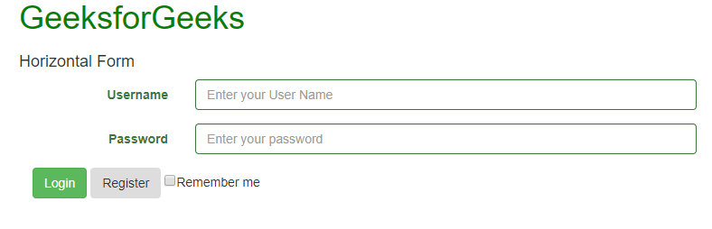

**Inline Forms:**

As the name suggests, in an inline form, all of the elements are inline, left-aligned, and the labels are alongside. You just need to add the class=”form-inline” in the form element.

Using the class=”sr-only” you can hide the labels of the inline forms which might cause problems sometimes.

You can also add glyphicons inside the forms. For that, you have to add class=”has-feedback” and add the span tag in which the glyphicon is present after the <input> tag. Remember adding form-control-feed as the class of the span tag.

**Example:**

* HTML

|  |
| --- |
| <!DOCTYPE html>  <**html** lang="en">  <**head**>      <**title**>Bootstrap Example</**title**>      <**meta** charset="utf-8">      <**meta** name="viewport"          content="width=device-width, initial-scale=1">      <**link** rel="stylesheet" href=  "<https://maxcdn.bootstrapcdn.com/bootstrap/3.4.0/css/bootstrap.min.css>">      <**script** src=  "<https://ajax.googleapis.com/ajax/libs/jquery/3.4.0/jquery.min.js>">      </**script**>      <**script** src=  "<https://maxcdn.bootstrapcdn.com/bootstrap/3.4.0/js/bootstrap.min.js>">      </**script**>  </**head**>  <**body**>      <**div** class="container" style="color:green">          <**h1**>GeeksforGeeks</**h1**>      </**div**>      <**div** class="container">          <**h4**>Inline Form</**h4**>          <**br**>          <**form** class="form-inline" action="/action\_page.php">              <**label** for="email">Username:</**label**>              <**input** type="email" class="form-control"                  id="email" placeholder="Enter Username"                  name="email">              <**label** for="pwd">Password:</**label**>              <**input** type="password" class="form-control"                  id="pwd" placeholder="Enter password"                  name="pswd">              <**button** type="button" class="btn btn-danger">                  Login              </**button**>              <**button** type="button" class="btn btn-secondary">                  Register              </**button**>          </**form**>      </**div**>  </**body**>  </**html**> |

**Output:**

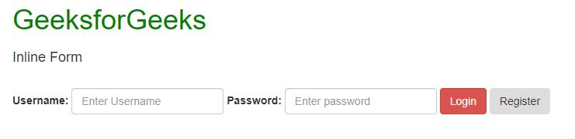

**Supported Browsers:**

* Google Chrome
* Internet Explorer
* Firefox
* Opera
* Safari